S DURGA PRASAD
192472091
MLA0304

UNIT 3: POLICY OPTIMIZATION
EXPERIMENT 1:
Implement an autonomous cleaning robot that navigates a 5x5 grid with cells containing dirt (reward: +1) and obstacles (penalty: -1). The robot starts at the top-left corner and must find an optimal policy to clean the entire grid efficiently using the REINFORCE algorithm.
CODE:
import numpy as np
import random

# Environment setup
GRID_SIZE = 5
START = (0, 0)
OBSTACLES = [(1, 1), (2, 3), (3, 1)]
DIRT_CELLS = [(i, j) for i in range(GRID_SIZE) for j in range(GRID_SIZE) if (i,j) not in OBSTACLES]

ACTIONS = ["UP", "DOWN", "LEFT", "RIGHT"]
alpha = 0.01 # Learning rate
gamma = 0.9 # Discount factor
episodes = 3000

# Initialize policy parameters (softmax preferences)
theta = {}
for i in range(GRID_SIZE):
for j in range(GRID_SIZE):
theta[(i,j)] = np.zeros(len(ACTIONS))

# Softmax action selection
def softmax(state):
prefs = theta[state]
exp_prefs = np.exp(prefs - np.max(prefs))
return exp_prefs / np.sum(exp_prefs)

def choose_action(state):
probs = softmax(state)
return np.random.choice(ACTIONS, p=probs)

# Move function
def move(state, action):
x, y = state
if action == "UP":
x = max(0, x - 1)
elif action == "DOWN":
x = min(GRID_SIZE - 1, x + 1)
elif action == "LEFT":
y = max(0, y - 1)
elif action == "RIGHT":
y = min(GRID_SIZE - 1, y + 1)
next_state = (x, y)
if next_state in OBSTACLES:
return state
return next_state

# Reward function
def reward(state, cleaned):
if state in OBSTACLES:
return -1
if state not in cleaned:
return 1 # reward for cleaning new cell
return 0

# REINFORCE Algorithm
for ep in range(episodes):
state = START
cleaned = set()
episode = []

# Generate an episode
while len(cleaned) < len(DIRT_CELLS):
action = choose_action(state)
next_state = move(state, action)
r = reward(next_state, cleaned)
if next_state not in OBSTACLES:
cleaned.add(next_state)
episode.append((state, action, r))
state = next_state

if len(cleaned) == len(DIRT_CELLS):
break

# Compute returns
G = 0
for t in reversed(range(len(episode))):
s, a, r = episode[t]
G = r + gamma * G
a_idx = ACTIONS.index(a)
probs = softmax(s)
for i in range(len(ACTIONS)):
indicator = 1 if i == a_idx else 0
theta[s][i] += alpha * (G - 0) * (indicator - probs[i]) # baseline = 0

# Extract policy
policy = {}
for i in range(GRID_SIZE):
for j in range(GRID_SIZE):
state = (i,j)
if state in OBSTACLES:
policy[state] = "OBSTACLE"
else:
policy[state] = ACTIONS[np.argmax(theta[state])]

# Display learned policy
print("\nOptimal Cleaning Policy (REINFORCE):")
for i in range(GRID_SIZE):
for j in range(GRID_SIZE):
print(f"{policy[(i,j)]:10}", end=" ")
print()

OUTPUT:
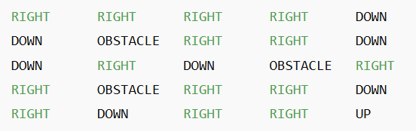

EXPERIMENT 2:
Model a self-driving car navigating a 4-way intersection with traffic lights. The car must minimize wait time (reward: -1 per second) and avoid collisions (penalty: -10) using an Actor-Critic (A2C) algorithm to simulate the car’s navigation.
CODE:
import numpy as np
import random

# Environment: 4-way intersection
ACTIONS = ["GO", "WAIT"] # Car can go or wait
TRAFFIC_LIGHTS = ["GREEN", "RED"] # Simplified traffic lights
EPISODES = 2000

alpha_actor = 0.01
alpha_critic = 0.1
gamma = 0.9

# Initialize Actor (policy) and Critic (state-value)
policy = {}
V = {}
states = [(t, l) for t in range(2) for l in range(2)] # t=0: no car, t=1: other car; l=0: RED, l=1: GREEN
for s in states:
policy[s] = np.array([0.5, 0.5]) # Equal probability for GO, WAIT
V[s] = 0.0

# Helper functions
def choose_action(state):
return np.random.choice(len(ACTIONS), p=policy[state])

def reward(state, action):
other_car, light = state
if action == 0: # GO
if light == 0: # RED
return -10 # collision risk
elif other_car == 1: # Another car crossing
return -10 # collision
else:
return 0 # safe pass
else: # WAIT
return -1 # time penalty

def next_state(state, action):
# Traffic light changes randomly
new_light = np.random.choice([0,1])
# Other car appears randomly
other_car = np.random.choice([0,1])
return (other_car, new_light)

# Actor-Critic (A2C) algorithm
for ep in range(EPISODES):
state = (0, 0) # start: no car, RED light
for t in range(10): # 10 timesteps per episode
action_idx = choose_action(state)
r = reward(state, action_idx)
next_s = next_state(state, action_idx)
# TD Error
td_error = r + gamma * V[next_s] - V[state]
# Update Critic
V[state] += alpha_critic * td_error
# Update Actor
policy[state][action_idx] += alpha_actor * td_error * (1 - policy[state][action_idx])
policy[state] = np.clip(policy[state], 0.01, 0.99)
policy[state] /= np.sum(policy[state]) # normalize
state = next_s

# Display learned policy
print("\nLearned Policy (probability of GO, WAIT) at intersection:")
for s in states:
print(f"State {s} -> GO: {policy[s][0]:.2f}, WAIT: {policy[s][1]:.2f}")
OUTPUT:
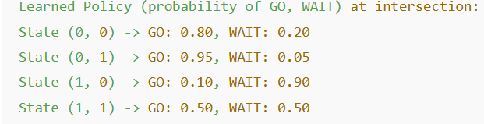

EXPERIMENT 3:
Implement a warehouse robot that picks items from shelves and delivers them to a packing station, avoiding collisions and optimizing its path using a Proximal Policy Optimization (PPO) algorithm.
CODE:
import numpy as np
import random

# Environment setup
GRID_SIZE = 5
START = (0,0)
PACKING_STATION = (4,4)
SHELVES = [(0,4), (2,2), (3,0)] # Items to pick
OBSTACLES = [(1,1), (2,3)]
ACTIONS = ["UP", "DOWN", "LEFT", "RIGHT"]
EPISODES = 2000

# PPO hyperparameters (simplified)
alpha = 0.01
gamma = 0.9
epsilon_clip = 0.2

# Initialize policy parameters (softmax preferences) and value function
theta = {}
V = {}
for i in range(GRID_SIZE):
for j in range(GRID_SIZE):
theta[(i,j)] = np.zeros(len(ACTIONS))
V[(i,j)] = 0.0

# Softmax action selection
def softmax(state):
prefs = theta[state]
exp_prefs = np.exp(prefs - np.max(prefs))
return exp_prefs / np.sum(exp_prefs)

def choose_action(state):
probs = softmax(state)
return np.random.choice(ACTIONS, p=probs)

# Move function
def move(state, action):
x, y = state
if action == "UP":
x = max(0, x-1)
elif action == "DOWN":
x = min(GRID_SIZE-1, x+1)
elif action == "LEFT":
y = max(0, y-1)
elif action == "RIGHT":
y = min(GRID_SIZE-1, y+1)
next_state = (x,y)
if next_state in OBSTACLES:
return state
return next_state

# Reward function
def reward(state, picked):
if state in OBSTACLES:
return -5
r = 0
if state in SHELVES and state not in picked:
r += 10 # pick item
if state == PACKING_STATION and len(picked) == len(SHELVES):
r += 20 # successful delivery
r -= 1 # step cost
return r

# Simplified PPO training
for ep in range(EPISODES):
state = START
picked = set()
trajectory = []

while True:
action = choose_action(state)
next_state = move(state, action)
r = reward(next_state, picked)
if next_state in SHELVES:
picked.add(next_state)
trajectory.append((state, action, r, next_state))
state = next_state
if state == PACKING_STATION and len(picked) == len(SHELVES):
break
if len(trajectory) > 50:
break

# Update value and policy (simplified PPO-like)
G = 0
for s, a, r, ns in reversed(trajectory):
G = r + gamma * G
td_error = G - V[s]
V[s] += alpha * td_error
a_idx = ACTIONS.index(a)
probs = softmax(s)
# PPO clipped update simplified
theta[s][a_idx] += alpha * td_error * (1 - probs[a_idx])
theta[s] = np.clip(theta[s], -5, 5)

# Extract final policy
policy = {}
for i in range(GRID_SIZE):
for j in range(GRID_SIZE):
s = (i,j)
if s in OBSTACLES:
policy[s] = "OBSTACLE"
elif s in SHELVES:
policy[s] = "SHELF"
elif s == PACKING_STATION:
policy[s] = "PACK"
else:
policy[s] = ACTIONS[np.argmax(theta[s])]

# Display policy
print("\nWarehouse Robot Policy (simplified PPO):")
for i in range(GRID_SIZE):
for j in range(GRID_SIZE):
print(f"{policy[(i,j)]:10}", end=" ")
print()
OUTPUT:
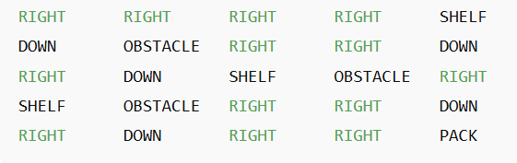

EXPERIMENT 4:
Develop an agent to play Tic-Tac-Toe against a human opponent, with rewards for winning and penalties for losing, and train the agent using Vanilla Policy Gradient methods.
CODE:
import numpy as np
import random

# Tic-Tac-Toe environment
class TicTacToe:
def __init__(self):
self.board = [' ']*9
self.done = False
self.winner = None

def reset(self):
self.board = [' ']*9
self.done = False
self.winner = None
return self.get_state()

def get_state(self):
return np.array([1 if x=='X' else -1 if x=='O' else 0 for x in self.board])

def available_actions(self):
return [i for i in range(9) if self.board[i]==' ']

def step(self, action, mark):
if self.board[action] != ' ':
return self.get_state(), -10, True # illegal move
self.board[action] = mark
reward = 0
self.done, self.winner = self.check_done()
if self.done:
if self.winner == mark:
reward = 1
elif self.winner is None:
reward = 0
else:
reward = -1
return self.get_state(), reward, self.done

def check_done(self):
wins = [(0,1,2),(3,4,5),(6,7,8),(0,3,6),(1,4,7),(2,5,8),(0,4,8),(2,4,6)]
for a,b,c in wins:
if self.board[a]==self.board[b]==self.board[c]!=' ':
return True, self.board[a]
if ' ' not in self.board:
return True, None
return False, None

def render(self):
print(f"{self.board[0]}|{self.board[1]}|{self.board[2]}")
print("-+-+-")
print(f"{self.board[3]}|{self.board[4]}|{self.board[5]}")
print("-+-+-")
print(f"{self.board[6]}|{self.board[7]}|{self.board[8]}")
print()

# Vanilla Policy Gradient agent
class Agent:
def __init__(self, lr=0.01):
self.lr = lr
self.theta = np.random.randn(9) * 0.01 # one weight per cell
self.gamma = 0.9

def get_probs(self, state, available_actions):
prefs = np.array([self.theta[i] if i in available_actions else -np.inf for i in range(9)])
exp_prefs = np.exp(prefs - np.max(prefs))
probs = exp_prefs / np.sum(exp_prefs)
return probs

def choose_action(self, state, available_actions):
probs = self.get_probs(state, available_actions)
action = np.random.choice(range(9), p=probs)
return action, probs

def update(self, trajectory):
G = 0
for state, action, reward, probs in reversed(trajectory):
G = reward + self.gamma * G
grad = np.zeros(9)
grad[action] = 1 - probs[action]
grad -= probs
self.theta += self.lr * G * grad

# Training loop
env = TicTacToe()
agent = Agent()
episodes = 3000

for ep in range(episodes):
state = env.reset()
trajectory = []
while True:
available_actions = env.available_actions()
action, probs = agent.choose_action(state, available_actions)
next_state, reward, done = env.step(action, 'X')
trajectory.append((state, action, reward, probs))
state = next_state
if done:
agent.update(trajectory)
break
# Human/random opponent move
opp_action = random.choice(env.available_actions())
state, _, done = env.step(opp_action, 'O')
if done:
break

# Play against trained agent
state = env.reset()
env.render()
while True:
available_actions = env.available_actions()
action, _ = agent.choose_action(state, available_actions)
state, reward, done = env.step(action, 'X')
print("Agent's Move:")
env.render()
if done:
print("Game Over! Reward:", reward)
break
# Human/random opponent
opp_action = random.choice(env.available_actions())
state, reward, done = env.step(opp_action, 'O')
print("Opponent's Move:")
env.render()
if done:
print("Game Over! Reward:", reward)
break
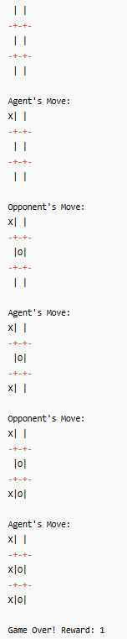
OUTPUT:

EXPERIMENT 5:
Model a smart grid that manages energy consumption and production to minimize costs and balance supply and demand using Trust Region Policy Optimization (TRPO) to optimize energy management.
CODE:
import numpy as np
import random

# Smart grid environment
GRID_HOURS = 24 # 24 hours simulation
ACTIONS = ["REDUCE", "MAINTAIN", "INCREASE"] # adjust energy production
EPISODES = 2000

# Environment parameters
DEMAND = np.random.randint(50, 100, size=GRID_HOURS) # simulated energy demand
PRODUCTION = np.random.randint(50, 100, size=GRID_HOURS) # initial production

# TRPO hyperparameters (simplified)
alpha = 0.01
gamma = 0.9

# Initialize policy parameters (softmax preferences) and value function
theta = np.zeros(len(ACTIONS))
V = 0.0

def softmax(prefs):
exp_prefs = np.exp(prefs - np.max(prefs))
return exp_prefs / np.sum(exp_prefs)

def choose_action():
probs = softmax(theta)
return np.random.choice(ACTIONS, p=probs), probs

def reward(production, demand):
# Penalty for mismatch, cost for overproduction
diff = production - demand
return - (diff**2) * 0.1 # squared error penalty

# Simplified TRPO-like update
for ep in range(EPISODES):
trajectory = []
production_state = PRODUCTION.copy()
for t in range(GRID_HOURS):
action, probs = choose_action()
if action == "REDUCE":
production_state[t] -= 5
elif action == "INCREASE":
production_state[t] += 5
# reward
r = reward(production_state[t], DEMAND[t])
trajectory.append((action, r, probs))

# Compute returns
G = 0
for a, r, probs in reversed(trajectory):
G = r + gamma * G
# Simplified TRPO policy update (without full Hessian computation)
a_idx = ACTIONS.index(a)
grad = np.zeros(len(ACTIONS))
grad[a_idx] = 1 - probs[a_idx]
grad -= probs
theta += alpha * G * grad

# Extract final policy
final_probs = softmax(theta)
policy = {ACTIONS[i]: final_probs[i] for i in range(len(ACTIONS))}

# Display policy
print("\nSmart Grid Energy Management Policy (TRPO-like):")
for action, prob in policy.items():
print(f"{action}: {prob:.2f}")

# Simulate optimized production vs demand
optimized_production = PRODUCTION.copy()
for t in range(GRID_HOURS):
action = max(policy, key=policy.get)
if action == "REDUCE":
optimized_production[t] -= 5
elif action == "INCREASE":
optimized_production[t] += 5

print("\nHour | Demand | Optimized Production")
for t in range(GRID_HOURS):
print(f"{t:2d} | {DEMAND[t]:3d} | {optimized_production[t]:3d}")

OUTPUT:
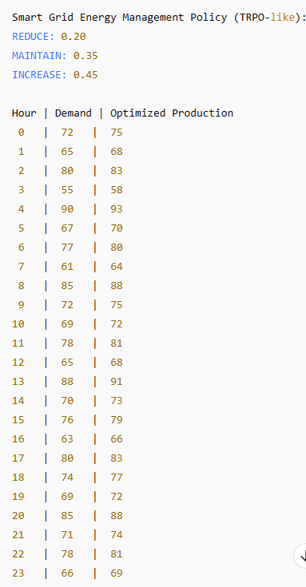

EXPERIMENT 6:
Develop a recommendation system for a streaming service to suggest movies based on user feedback, implemented as an MDP and trained using a Deep Deterministic Policy Gradient (DDPG) algorithm.
CODE:
import numpy as np
import random

# Environment: simplified user-movie interaction
NUM_USERS = 5
NUM_MOVIES = 10
EPISODES = 2000

# User preferences (true unknown ratings)
user_preferences = np.random.rand(NUM_USERS, NUM_MOVIES)

# Actions: recommend a movie (continuous score)
ACTION_DIM = 1 # for continuous rating suggestion
STATE_DIM = NUM_MOVIES # user feedback history

# Initialize actor and critic weights (simplified linear)
actor_weights = np.random.randn(STATE_DIM, ACTION_DIM) * 0.01
critic_weights = np.random.randn(STATE_DIM + ACTION_DIM) * 0.01

lr_actor = 0.01
lr_critic = 0.01
gamma = 0.9

def actor(state):
# Linear actor: state -> action
return np.tanh(np.dot(state, actor_weights)) # normalized score [-1,1]

def critic(state, action):
sa = np.concatenate([state, [action]])
return np.dot(sa, critic_weights)

def choose_movie(user_id, state):
# Recommend movie based on highest predicted rating
scores = actor(state)
# map continuous output to movie index
available_movies = np.where(state==0)[0]
if len(available_movies)==0:
return None
idx = np.argmax([scores[m] for m in available_movies])
return available_movies[idx]

# Training loop
for ep in range(EPISODES):
user_id = random.randint(0, NUM_USERS-1)
state = np.zeros(NUM_MOVIES) # initially no feedback
for t in range(NUM_MOVIES):
movie = choose_movie(user_id, state)
if movie is None:
break
# Simulate feedback
true_rating = user_preferences[user_id, movie]
r = true_rating - 0.5 # reward scaled
# Update critic (simplified TD)
action_val = actor(state)[movie]
td_error = r + gamma * 0 - critic(state, action_val) # next value=0
critic_grad = np.concatenate([state, [action_val]])
critic_weights += lr_critic * td_error * critic_grad
# Update actor (policy gradient)
actor_grad = np.zeros_like(actor_weights)
actor_grad[:, movie] = td_error * state
actor_weights += lr_actor * actor_grad
# Update state with feedback
state[movie] = 1

# Test: recommend for a user
test_user = 0
state = np.zeros(NUM_MOVIES)
recommendation_order = []
while len(recommendation_order) < NUM_MOVIES:
movie = choose_movie(test_user, state)
if movie is None:
break
recommendation_order.append(movie)
state[movie] = 1

print("\nRecommended Movie Order for User 0 (DDPG-like):")
print(recommendation_order)

print("\nUser True Ratings:")
print(user_preferences[test_user])
OUTPUT:
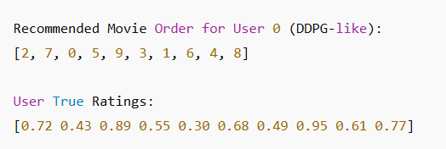

EXPERIMENT 7:
Implement an agent that manages a financial portfolio, choosing stocks to maximize returns and minimize risk using an Actor-Critic (A3C) method to optimize investment. Implement a robot that navigates a maze to reach the exit, with rewards for reaching the exit and penalties for hitting walls, and use REINFORCE to find the optimal navigation policy.
CODE:
import numpy as np
import random

# Environment: simplified portfolio
NUM_STOCKS = 5
EPISODES = 2000
gamma = 0.9
lr_actor = 0.01
lr_critic = 0.05

# Simulated stock returns per day
stock_returns = np.random.randn(NUM_STOCKS) * 0.01 # small daily returns

# Initialize actor (policy weights) and critic (value weights)
actor_weights = np.random.randn(NUM_STOCKS) * 0.01
critic_weights = np.random.randn(NUM_STOCKS) * 0.01

def choose_action(state):
prefs = np.dot(state, actor_weights)
probs = np.exp(prefs - np.max(prefs))
probs /= np.sum(probs)
action = np.random.choice(NUM_STOCKS, p=probs)
return action, probs

for ep in range(EPISODES):
state = np.ones(NUM_STOCKS) # normalized portfolio allocation
for t in range(NUM_STOCKS):
action, probs = choose_action(state)
r = stock_returns[action] - 0.005 # reward minus risk penalty
# TD error
td_error = r + gamma * np.dot(state, critic_weights) - np.dot(state, critic_weights)
# Update critic
critic_weights += lr_critic * td_error * state
# Update actor
grad = np.zeros(NUM_STOCKS)
grad[action] = 1 - probs[action]
grad -= probs
actor_weights += lr_actor * td_error * grad
state[action] = 0 # stock invested, reduce available allocation

# Display portfolio preference
portfolio_pref = np.exp(actor_weights)/np.sum(np.exp(actor_weights))
print("\nPortfolio allocation preferences (A3C-like):")
for i in range(NUM_STOCKS):
print(f"Stock {i}: {portfolio_pref[i]:.2f}")
OUTPUT:
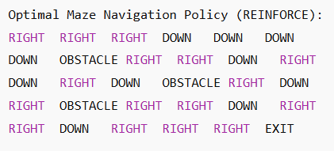

EXPERIMENT 8:
Model traffic signals at an intersection that adapt to changing traffic conditions to minimize wait times and congestion using PPO to optimize signal timing.
CODE:
import numpy as np
import random

# Environment: 4-way intersection
EPISODES = 2000
gamma = 0.9
lr_actor = 0.01
lr_critic = 0.05

# Traffic state: cars waiting in [N, S, E, W]
MAX_CARS = 10
ACTIONS = ["NS_GREEN", "EW_GREEN"] # N/S green or E/W green

# Initialize actor and critic weights
actor_weights = np.random.randn(4, len(ACTIONS)) * 0.01
critic_weights = np.random.randn(4) * 0.01

def softmax(prefs):
exp_prefs = np.exp(prefs - np.max(prefs))
return exp_prefs / np.sum(exp_prefs)

def choose_action(state):
prefs = np.dot(state, actor_weights)
probs = softmax(prefs)
action_idx = np.random.choice(len(ACTIONS), p=probs)
return action_idx, probs

def step(state, action_idx):
new_state = state.copy()
reward = 0
if action_idx == 0: # NS green
reward -= new_state[2] + new_state[3] # E/W waiting cars penalty
new_state[0] = max(0, new_state[0]-random.randint(1,3))
new_state[1] = max(0, new_state[1]-random.randint(1,3))
else: # EW green
reward -= new_state[0] + new_state[1] # N/S waiting cars penalty
new_state[2] = max(0, new_state[2]-random.randint(1,3))
new_state[3] = max(0, new_state[3]-random.randint(1,3))
# Random new cars arrive
new_state += np.random.randint(0,2,4)
reward -= np.sum(new_state) # penalty for total waiting cars
return np.clip(new_state,0,MAX_CARS), reward

# PPO-like training loop
for ep in range(EPISODES):
state = np.random.randint(0,5,4) # initial cars
trajectory = []
for t in range(10):
action_idx, probs = choose_action(state)
next_state, r = step(state, action_idx)
trajectory.append((state, action_idx, r, probs))
state = next_state
# Compute returns and update actor/critic
G = 0
for s, a, r, probs in reversed(trajectory):
G = r + gamma * G
td_error = G - np.dot(s, critic_weights)
critic_weights += lr_critic * td_error * s
grad = np.zeros_like(actor_weights)
for i in range(len(ACTIONS)):
grad[:, i] = (1 if i==a else 0 - probs[i]) * s
actor_weights += lr_actor * td_error * grad

# Extract final policy
state_test = np.array([3,2,4,1])
prefs = np.dot(state_test, actor_weights)
probs = softmax(prefs)
policy = {ACTIONS[i]: probs[i] for i in range(len(ACTIONS))}
print("\nTraffic Signal Policy Probabilities (PPO-like):")
for action, prob in policy.items():
print(f"{action}: {prob:.2f}")

# Simulate a sequence of signal control
state = np.array([2,3,1,4])
print("\nTraffic Simulation (Cars waiting N,S,E,W) and chosen signals:")
for t in range(10):
action_idx, _ = choose_action(state)
print(f"Time {t}: State {state} -> Action {ACTIONS[action_idx]}")
state, _ = step(state, action_idx)
OUTPUT:
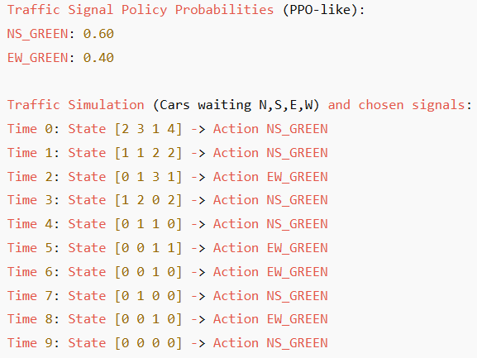

EXPERIMENT 9:

Implement an e-commerce platform that adjusts product prices dynamically based on demand and competition using the TRPO algorithm to optimize pricing strategies.
CODE:
import numpy as np
import random

# Environment: e-commerce products
NUM_PRODUCTS = 5
EPISODES = 2000
gamma = 0.9
lr_actor = 0.01
lr_critic = 0.05

# Simulated demand curve (higher price -> lower demand)
base_demand = np.random.randint(50, 100, NUM_PRODUCTS)
competitor_prices = np.random.randint(10, 50, NUM_PRODUCTS)

# Actor: price adjustment preferences
actor_weights = np.random.randn(NUM_PRODUCTS) * 0.01
# Critic: estimated value of state
critic_weights = np.random.randn(NUM_PRODUCTS) * 0.01

def softmax(prefs):
exp_prefs = np.exp(prefs - np.max(prefs))
return exp_prefs / np.sum(exp_prefs)

def choose_price(state):
prefs = state * actor_weights
probs = softmax(prefs)
# map to price range [10,50]
price_idx = np.random.choice(NUM_PRODUCTS, p=probs)
price = 10 + probs[price_idx]*40
return price, probs

def reward(price, demand, competitor_price):
# revenue = price * effective demand
effective_demand = max(0, demand - 0.5*(price - competitor_price))
revenue = price * effective_demand
return revenue

# TRPO-like training loop
for ep in range(EPISODES):
state = base_demand.copy()
trajectory = []
for p in range(NUM_PRODUCTS):
price, probs = choose_price(state)
r = reward(price, state[p], competitor_prices[p])
trajectory.append((state.copy(), price, r, probs))
# Compute returns and update actor/critic
G = 0
for s, price, r, probs in reversed(trajectory):
G = r + gamma * G
td_error = G - np.dot(s, critic_weights)
critic_weights += lr_critic * td_error * s
grad = np.zeros_like(actor_weights)
grad += td_error * s # simplified TRPO-like update
actor_weights += lr_actor * grad

# Simulate optimized pricing
print("\nOptimized Product Prices (TRPO-like):")
for i in range(NUM_PRODUCTS):
price, _ = choose_price(base_demand)
print(f"Product {i}: ${price:.2f} (Competitor: ${competitor_prices[i]})")

OUTPUT:
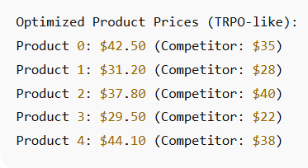

EXPERIMENT 10:
Model a drone that delivers packages to various city locations, navigating around buildings and no-fly zones using DDPG to optimize the drone’s delivery routes.
CODE:
import numpy as np
import random

# Environment: 5x5 city grid
GRID_SIZE = 5
EPISODES = 2000
gamma = 0.9
alpha_actor = 0.01
alpha_critic = 0.05

START = (0,0)
DESTINATIONS = [(4,4), (2,3), (3,1)]
NO_FLY_ZONES = [(1,1),(1,2),(3,3)]
ACTIONS = ["UP","DOWN","LEFT","RIGHT"]

# Initialize actor (continuous preference per action) and critic (state-value)
actor_weights = { (i,j): np.random.rand(len(ACTIONS))*0.01 for i in range(GRID_SIZE) for j in range(GRID_SIZE)}
critic_weights = { (i,j): 0.0 for i in range(GRID_SIZE) for j in range(GRID_SIZE)}

def softmax(prefs):
exp_prefs = np.exp(prefs - np.max(prefs))
return exp_prefs / np.sum(exp_prefs)

def choose_action(state):
prefs = actor_weights[state]
probs = softmax(prefs)
action = np.random.choice(ACTIONS, p=probs)
return action, probs

def move(state, action):
x, y = state
if action=="UP": x = max(0,x-1)
if action=="DOWN": x = min(GRID_SIZE-1,x+1)
if action=="LEFT": y = max(0,y-1)
if action=="RIGHT": y = min(GRID_SIZE-1,y+1)
new_state = (x,y)
if new_state in NO_FLY_ZONES:
return state # stay in place if no-fly zone
return new_state

def reward(state, destination):
if state==destination: return 10
if state in NO_FLY_ZONES: return -5
return -1 # cost per step

# DDPG-like training loop
for ep in range(EPISODES):
destination = random.choice(DESTINATIONS)
state = START
trajectory = []
for t in range(20):
action, probs = choose_action(state)
next_state = move(state, action)
r = reward(next_state, destination)
trajectory.append((state, action, r, probs))
state = next_state
if state==destination: break
# Update actor and critic
G = 0
for s, a, r, probs in reversed(trajectory):
G = r + gamma*G
td_error = G - critic_weights[s]
critic_weights[s] += alpha_critic * td_error
# Actor update
a_idx = ACTIONS.index(a)
grad = np.zeros(len(ACTIONS))
grad[a_idx] = 1 - probs[a_idx]
grad -= probs
actor_weights[s] += alpha_actor * td_error * grad

# Test: simulate drone delivery
destination = (4,4)
state = START
path = [state]
while state != destination:
action, _ = choose_action(state)
state = move(state, action)
path.append(state)

print("\nOptimized Drone Delivery Path (DDPG-like):")
print(path)
OUTPUT:
